BT 603 – current solved past paper
- Fermentation actually comes from Latin word “fervere” which means “to boil”
- Fermentation can be classified into different types on the basis of followings:
  - Oxygen (O₂) Need
  - Production Scale
  - State/Mixing
  - All of above
- Pilot and industrial scale fermentations are normally carried out in stirred, aerated vessels
- Examples of Bioweapons
  - Smallpox
  - Anthrax
  - Botulinum toxin
  - All of above
- Constitutive enzyme: An enzyme that is synthesized continually regardless of growth conditions.
- In 1900-1940 Citric acid is produced
- On the basis of state or mixing fermentation can be Shake-Flask Fermentation
- Downstream Processing includes the recovery of the products in a pure state and the effluent treatment.
- A medium with a high viscosity will also need a higher power input for effective stirring
- Reducing media contain ingredients, such as sodium thioglycolate, that chemically combine with dissolved oxygen and deplete the oxygen in the culture medium.
- Cellular yield coefficient of n-alkanes 1.03
- Carbohydrate composition of barley malt (expressed as % dry weight of total) of Reducing sugars 3-4
- Trace element Mn influencing primary and secondary metabolites production of Bacitracin
- In processes used for the production of glutamic acid, limited concentrations of biotin must be present in the medium
- Phenylacetic acid is still the most widely used precursor in penicillin production.
- potential chlorination inhibitors, e.g. bromide,
- heterologous proteins may show some degree of toxicity to the host and have a major influence on the stability of heterologous protein expression.
- The individual components of the medium can influence the viscosity of the final medium and its subsequent behaviour with respect to aeration and agitation.
- Trace elements were increased; insulin, transferrin, albumin and liposomes were not needed included Co
- The foaming can cause removal of cells from the medium which will lead to autolysis
- The foam is unavoidable and antifoam should be used.
- many antifoams are of low solubility
- independent variable (nutrient, antifoam, pH, temperature, etc.)
- When more than five independent variables are to be investigated, the Plackett-Burman design may be used
- The oxygen demand of an industrial fermentation process is normally satisfied by aerating and agitating the fermentation broth.
- The solubility of oxygen in pure water is 8 mg/L at 4ºC.
- Production of 100 grams of biomass from hydrocarbon requires approximately three times the amount of oxygen to produce the same amount of biomass from carbohydrate.
- maximum biomass production may be achieved by satisfying the organism's maximum specific oxygen demand by maintaining the dissolved oxygen concentration greater than the critical level
- Sulphite Oxidation technique does not require the measurement of dissolved oxygen concentrations
- Two methods have been employed to achieve this lowering of the dissolved oxygen concentration - the static method and the dynamic method.
- (NCTC) abbreviation of? National Collection of Type cultures
- The isolation method most commonly used to get pure cultures is the streak plate method
- lyophilization (freeze-drying)
- the process of
- strain improvement involves the continual genetic modification of the culture,
- Protoplast fusion has been demonstrated as an efficient way to induce hetero-karyon formation and recombination with high frequency.
- Auxotrophy is the inability of an organism to synthesize a particular organic compound required for its growth
- The quantity of inoculum normally used is between 3 and 10% of the medium volume
Q:- what is Site-Directed Mutagenesis? (2)
- Site-specific mutation commonly involve using mutagenic oligonucleotides in a primer extension reaction with DNA polymerase.
- This method allows for point mutation, or deletion or insertion of small stretches of DNA to be introduced at specific sites.
Q: Two examples of Methylotrophic yeasts?
Methylotrophic yeasts such as Hansenula polymorpha and Pichia pastoris
Q: Draw a graph showing The effect of dissolved oxygen concentration on the Q_{O2} of a microorganism?
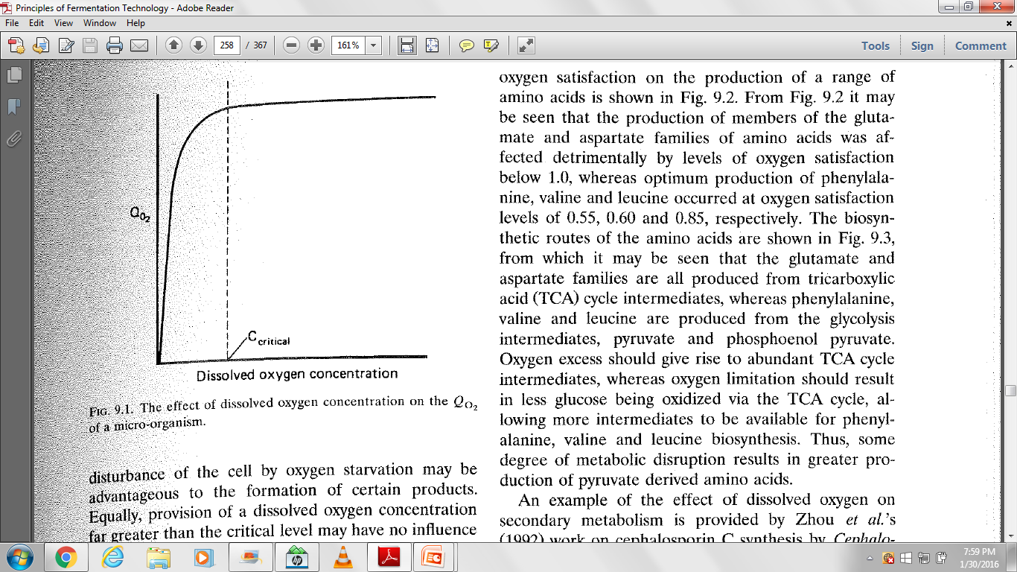
Q: Define Henry’s Law?
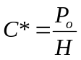Henry’s Law describes the solubility of O₂ in nutrient solution in relation to the O₂ partial pressure in the gas phase

C* is the oxygen saturation concentration of the nutrient solution,
P_{o} is the partial pressure of the gas in the gas phase
H is Henry's constant, which is specific for the gas and the liquid phase.
Q: Bull et al. (1979) cited criteria in the choice of process organism? (10)
Q: What is Replica Plating Method? (5)
Mutants can be detected by selecting or testing for an altered phenotype. Positive selection involves the selection of mutant cells and rejection of non-mutated cells. To identify mutants that have gained some physical trait, Replica plating is used for negative selection. Negative selection identifies mutants that have lost some physical trait - for example, auxotrophs that have nutritional requirements not possessed by the parent (nonmutated) cell.
Q: Draw a flow chart for INDUSTRIAL STRATEGY FOR USAGE OF MICROORGANISMS? (5)

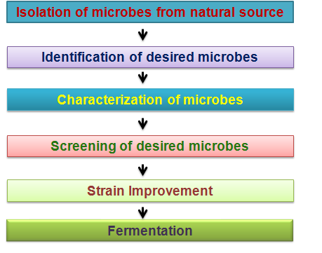
Q: Phenotypic characteristics to characterize and identify microorganisms (3)?
    - Microscopic morphology
    - Metabolic differences (Biochemical Testing)
    - Serology
    - Fatty acid analysis

Q: Name Trace elements use in fermentation media, any five (3)
The role of trace elements in medium formulation can be significant. Fe, Zn, Cu, Se, Mn, Mo and V. AI, Ag, Ba, Br, Cd, Co, Cr, F, Ge, J, Rb, Zr, Si, Ni and Sn

